**Q. Web Evolution from 1.0 to 3.0 or Evolution of web**

Ans: The evolution happened in web from web 1.0 to 2.0 and to web

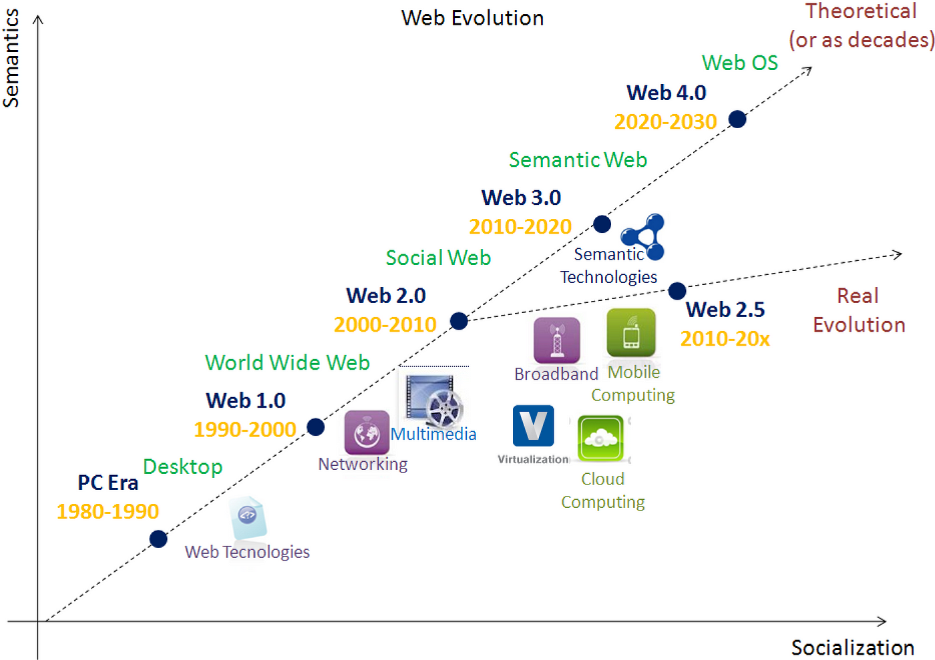

The first version of web **Web 1.0** also referred as Syntactic web or read only web is the era (1990–2000) where the role of a user is limited to reading information provided by the content producers. There is no option given for user or consumer to communicate back the information to the content producers. Example of Web 1.0 are static web sites and personal sites.

The **Web 2.0** also referred as Social Web or read-write web is the era (2000–2010 and continues even now) which facilitates interaction between web users and sites which intern allows users to communicate with other users. In this era every user can be a content producers and content are distributed and shared between sites. Some of the famous Web 2.0 applications are Facebook, YouTube, Flickr, Twitter etc., The web technologies like HTML5, CSS3 and JavaScript frameworks like ReactJs, AngularJs, VueJs etc., enables startups to innovate new ideas which enables users to contribute more in this Social Web. Web 2.0 is built around the users, producer just need build a way to enable and engage them.

The **Web 3.0** also referred as Semantic Web or read-write-execute is the era (2010 and above) which refers to the future of web. In this era computers can interpret information like humans via Artificial Intelligence and Machine Learning. Which help to intelligently generate and distribute useful content tailored to a particular need of a user.

* What if computers can understand meaning behind information
* What if they can learn “what we are interested in”
* Then they can help us find what we want
* It can recognize People, Place, Events, Companies, Product, Movies etc.,
* The **Web 2.5** is the concept to address the practical and real evolution which we are currently seeing in our era 2010–2020 between Web 2.0 and 3.0. On our way to Web 3.0 some of player like [Amazon](https://aws.amazon.com/), [Google](https://cloud.google.com/), [Salesforce](https://www.salesforce.com/), [KiSSFLOW](https://kissflow.com/" \t "_blank) etc., provides a service model in Cloud computing for developers to create web applications for their users to connect them on any devices, anytime and anywhere.
* It can understand the relationship between things.

Some of the examples of web 3.0 are [Apple’s Siri](https://www.apple.com/ios/siri/), [Googles Cloud API](https://cloud.google.com/products/machine-learning/), [Wolfram Alpha](http://wolframalpha/).

Q.